STUDY INFORMATION AND INFORMED CONSENT
Frequently Asked Questions
Introduction
The purpose of this document is to provide essential information about how personal data is processed in biomedical research. It explains sections of the Informed Consent Form (ICF) that reference the processing of personal data and related research and development processes.
This document answers frequently asked questions about the ICF that was produced by Work Package 4 of the Innovative Medicines Initiative project BD4BO DO-IT. It is intended for study participants who are taking part in clinical studies that use the DO-IT ICF.
When this Frequently Asked Questions document is used to compliment the ICF it is to be submitted to Institutional Review Boards (IRB)/Ethics Committees (EC) for review.

[Include Sponsor’s logo]

STUDY INFORMATION AND INFORMED CONSENT
Frequently Asked Questions
Part 1: Your personal data
1. | What is a sponsor?
 | A sponsor is a person, company, institution, group, or organisation that oversees or pays for a clinical study and collects and analyses the data. The sponsor has the overall responsibility for a clinical study.
2. | What is a CRO?
 | A contract research organisation (CRO) is a company that provides support to the sponsor in the form of research services outsourced on a contract basis. E.g. the CRO may do the analysis of your blood samples.
3. | What is a study site?
 | The place where a clinical study is conducted, and where you go to participate in the study e.g. your hospital.

4. | What is coded data?
Coded data is information related to study participants identified by a random code. For example, data may be identified using a patient number instead of anything that may directly identify you such as your name, address, phone number or national identification number.
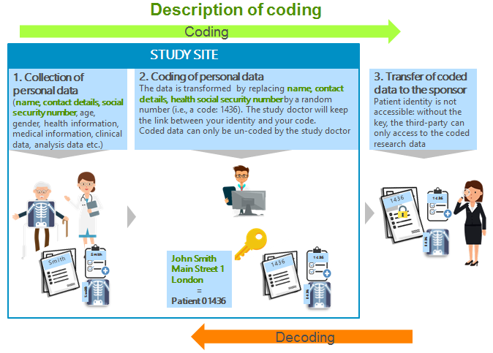
The image below illustrates the coding process.

5. | What is anonymised data?
It is your clinical data stripped of your patient number as well as of any other information that could identify you such as your exact height and weight and exact visit dates.
The image below illustrates the anonymisation process.
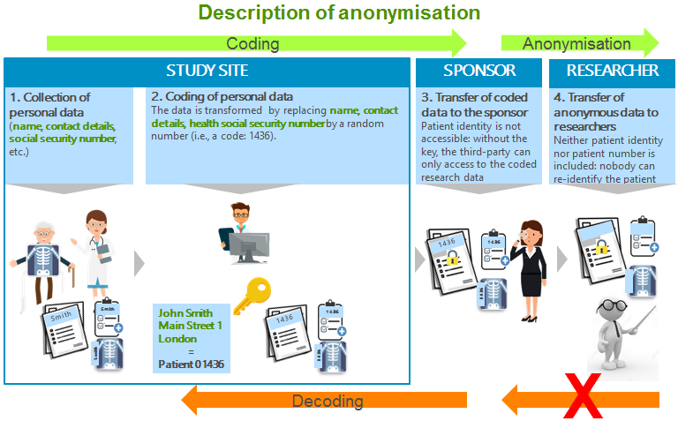
6 | Can I refuse to provide my data and still participate in a clinical study?
 | No. Data from clinical studies are necessary to evaluate the safety and efficacy of the pharmaceutical product. It is also used by regulatory authorities to assess if the study results are correct. However, it is your choice whether or not to participate in a clinical study.
7 | If I stop participating in the clinical study, what will happen to my data?
 | The data that has been collected until you leave the study will be used as described in the informed consent form you signed. It will not be possible to delete data that has already been collected for the study due to laws and regulations that apply to clinical studies.
8. | Can I ask for my data to be deleted?
No. Most data that has already been collected, which is required for the performance of the study, will not be deleted. This is due to laws and regulations that require the study doctor as well as the sponsor to retain the data.
However, data that is not essential to the study or protected by legal requirements can be deleted.

9. | Can I refuse to have my medical records at the study site accessed by anyone other than the study doctor and their staff?
 | No. Authorised individuals of the sponsor and applicable regulatory authorities can access information such as your medical records at the study site. This is done so the sponsor and regulatory authorities can make sure the study respects applicable laws and regulations. It also minimises the risk of fraud in clinical study. Individuals who need to access your medical records at the study site are bound by confidentiality.
10. | Can I be sure that individuals who access my medical records at the study site are respecting my confidentiality?
 | Everyone who accesses your medical records at the study site is bound by confidentiality. Your medical records are kept at the study site. The sponsor will only receive coded data.
11. | I understand that my data will be coded before it is sent to the sponsor. Does that mean that the data sent to the sponsor is anonymous?
 | No, the coded data is not anonymous. Please see questions 3 and 4 for more information about coded and anonymised data.
12. | Can I be identified from my coded data?
 | Yes, but the risk of being identified is very minimal. This is because the coded data do not contain information that directly identifies you such as your name, address, phone number, date of birth or national identification number. The risk of identification may be higher if you have a rare diseases or specific health conditions, especially if you share equivalent data on the Internet.
13. | How is my data shared with other parties?
Your directly identifiable data (such as medical records related to your name or X-rays with your name printed on them) will not be shared. They would only be accessed on-site or under the control of the study doctor for verification purposes.
Coded data will be shared with the sponsor and companies such as Clinical Research Organisations (CROs) that work on behalf of the sponsor.
Coded data will also be shared with regulatory authorities for prior review and approvals that need to take place before a sponsor is allowed to market the drug.
14. | Will my data be transferred to other countries?
 | Yes, your coded data may be transferred to other countries, including those with different data protection laws. However, the sponsor is responsible for ensuring that the transfer of your coded data is done in compliance with European legislation.
15. | Can you describe how my data is protected when it is transferred and shared with other parties?
 | Any transfer or sharing of data to companies such as Clinical Research Organisations (CROs) is governed by contracts. These require such companies to only access and use the data for the purpose specified in the contract with appropriate technical and organisational measures.

16. | What will the sponsor do with the coded data?
The sponsor can only use your coded data for the purpose agreed in the informed consent form.
Your clinical study is only a small part of the process the sponsor must follow to put a new drug on the market. Therefore, the coded data collected for the clinical study will be used in all steps of the drug development programme including:
- To conduct the study;
- To check that the study is carried out as required by law;
- To publish summaries of study results which will never disclose your identity;
- To comply with regulatory duties including regulations on clinical studies, safety, and authorisation of the drug commercialisation;
- To conduct further research as may be specified in the informed consent form, where applicable.

17. | Can the coded data that is provided to the sponsor be sold to other parties?
No, your coded data will not be sold. However, in instances where the sponsor is selling parts of its business to another pharmaceutical company, a copy of your coded data would be transferred to the new company using the same data protection standards.
The coded data will only be processed for the purposes described in the informed consent form.
18. | Is there a risk that I may suffer from discrimination based on the health data resulting from the clinical study?
 | No, the data that is collected and processed in a clinical study can only be used for the purpose described in the informed consent form. Neither the sponsor nor the study doctor has the right to share the data with parties such as your employer or an insurance company. In addition, the sponsor and the CRO will only have coded data.
19. | I understand that the result of the clinical study may be published e.g. in scientific journals. May I be identified in such a publication?
No. Your individual data will be anonymised before being published. Only aggregated or anonymised information will be published.

Aggregated information is statistical summaries, where no individual patient can be identified.
20. | Why will my data be stored for at least 25 years?
 | The current law in the EU requires that the data must be kept for 25 years. However, countries outside the EU may impose a longer retention period. Therefore, the coded data must be kept for the length of the longest mandatory retention period to which the sponsor is subject to. The length of time data must be stored is directly related to the time a particular drug is available on the market.
21. | Can I contact the sponsor for more information about how they are processing my data, and to request access to my data?
 | Only the study site and your study doctor have your fully identifiable data. To get more information about the processing of your data you can contact your study doctor who can make such a request on your behalf.

22. | Why do I need to wait until the end of the study to get access to some of the data?
 | During a clinical study, certain data cannot be disclosed until the study is completed, to avoid compromising the research. For example, in a double-blind study the treatment cannot be disclosed until the study is completed. A double-blind study is one in which neither the study participants nor the study doctors know who is receiving which particular treatment. This procedure is utilised to prevent bias in study results.
23. | Why may there be a need to collect information about race and ethnic background?
 | This information will only be collected in countries where it is required such as the USA. It may be used to find out if race and ethnicity affect how the drug works in different populations.
24. | Will I be informed if the sponsor discovers something related to my health such as the existence of a certain health condition or an increased risk of a specific health issue?
 | The sponsor will tell the study doctor if they discover something that may be life-threatening and actionable, so you can be informed.

Part 2: Your biosamples such as blood, urine, biopsies and surgical waste
25. | Who will have access to my biosamples?
 | The study doctor and staff at the study site, as well as individuals working on behalf of the sponsor, will have access to your biosamples.
26. | Will my biosamples be protected?
 | Yes, the study site as well as the sponsor are responsible for ensuring that your biosamples are securely stored to prevent that unauthorised individuals can access the biosamples. The study site and the sponsor are also responsible for ensuring that the required storage conditions (e.g. correct temperature) are maintained.
27. | Will my privacy be protected with respect to my biosamples?
 | Yes. Your biosamples are labelled in the same way as your data. Biosamples are labelled with your patient identification number. No direct identifiers will be included on the biosample labels.
28. | Who will review my tests results?
 | The study doctor and staff at the study site will review the tests results. The sponsor and staff working on behalf of the sponsor will only get the coded results after it has been reviewed by the study team.
29. | Will the results of the blood tests become part of my medical record?
 | Results that are relevant for diagnosis or treatment become part of your medical record and those results required by applicable law.
30. | What will happen to my biosamples if I withdraw my consent for participating in the study?  Any biosamples that are not required by law or regulation to be stored will be destroyed.
31. | Will my biosamples be used for purposes other than the clinical study, and beyond the end of the clinical study?
 | Yes, but only for analysis required for the drug development programme or if you have agreed that your biosamples may be used for future research.
32. | If I agree to my biosamples being used in future research, will I get information about which laboratory tests have been made on my biosamples and the results of these tests?
No, because future research is not equivalent to healthcare tests. What is done with biosamples in future research is most often not conducted in a healthcare validated environment and is therefore not a test result.
However, if the research team generates information that is life-threatening and actionable, they would inform the study site unless the sample has been fully anonymised. The study site would then contact you and you would be able to do equivalent tests to confirm the finding.
If you want to know more about what is being done with your samples, you can ask your study doctor to contact the sponsor for this information.
33. | What will happen to the biosamples if I withdraw my consent for future use?
 | Any biosamples that are not required by law or regulation to be stored will be destroyed.

